**Instructions:**Replace **[bracketed red text]** with the requested information or screen capture.  
Replace **bracketed red text with black text**.  
**PLEASE do not include full page, full window screen shot images**, or full screen shots that have been reduced in size.   
Use a snippet tool to capture parts of the screen and insert those images into the template.  
**Do not remove tags from this template. An example of a tag is [C01]. All fields are required.***Please do not alter template formatting or delete parts of this template.*

Part A - Student Information:   
 **1. Student Name: Abel Marin**

**2. What day and date did you start this tutorial? Sunday March 8, 2020**

Go back to the instructions and continue with Part B.Part B –CMS Shared Webhost Information:

**1. Which shared web host did you use for this part of the assignment?** **[SiteGround] [B1]**

Enter your shared web host Drupal 8 site information below:   
  
B.1 New Drupal 8 Site on your Shared Web Host:

1. **Assignment Website In-Directory Name:** **[**tutorial09**]**
2. **Assignment MySQL Database Information**
   * **Database Name:** **[drup549]**
   * **Table Prefix:** **[drss_]**
3. **WEBSITE Admin Username:** **[ajmarin]**
4. **WEBSITE Admin Password:** **[9UX1t@@&yd]**
5. **Assignment Website URL:** **[http://abelm.sgedu.site/tutorial09]**
6. SCREEN CAPTURE – Backend Account Settings, REGISTRATION AND CANCELLATION  
   Admin toolbar > Configuration > Account settings, Registration and Cancelation[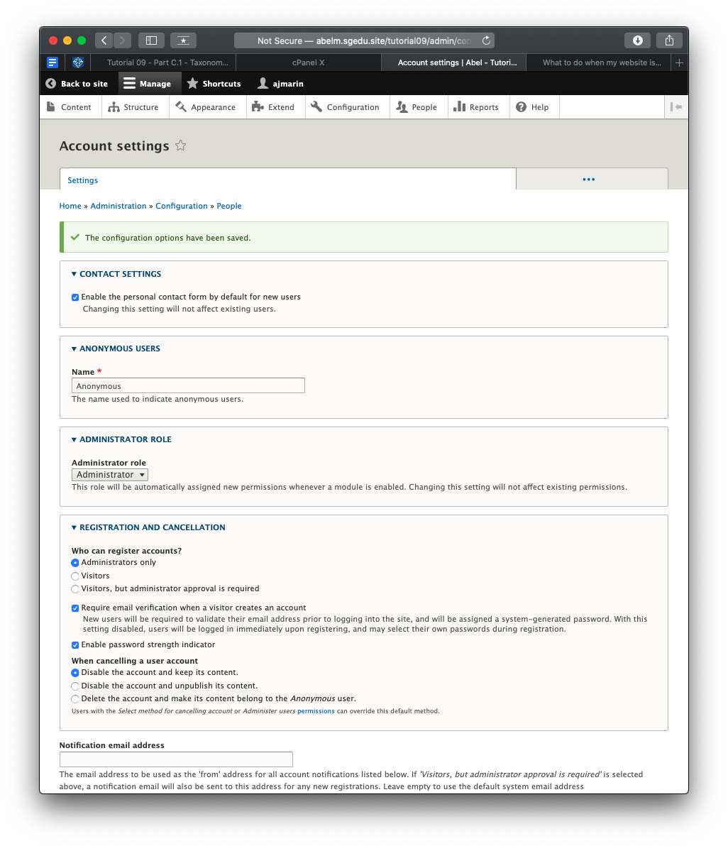]
7. Go back to the instructions and continue with Part C.

B.2 -OR- if you used Pantheon (PA) fill out the information below:

1. **Pantheon Account Info:** 
   * **Pantheon Account Email: [Your Pantheon Account Email]**
   * **Pantheon Password: [Your Pantheon Account Password]**
2. **Pantheon Site Name:** **[SITE NAME]**
3. **WEBSITE Admin Username:** **[ADMIN USERNAME]**
4. **WEBSITE Admin Password:** **[ADMIN PASSWORD]**
5. **Pantheon site URL: [Your Pantheon CMS Site URL]**
6. SCREEN CAPTURE – Backend Account Settings, REGISTRATION AND CANCELLATION  
   Admin toolbar > Configuration > Account settings, Registration and Cancelation[SCREEN CAPTURE HERE]

B.3 Share Web Host Cleanup memory and INode free space   
* Only For shared web hosts with cPanel

1. **Backend screen capture that of your shared web host cPanel showing the free memory and iNode space:**   
   **[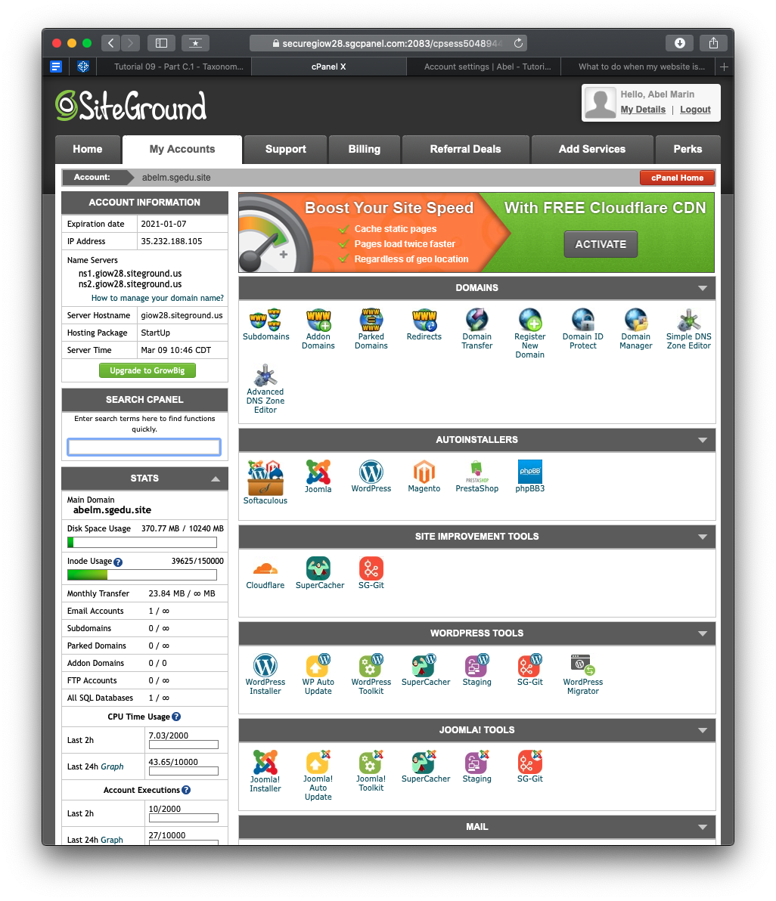]**

Go back to the instructions and continue with Part C.

Part C – Extending Drupal with Taxonomy+Vocabulary+Terms

Shared Web Host Drupal 8 Screen Captures:

1. SCREEN CAPTURE – Backend Taxonomy List of Vocabularies.   
   Admin toolbar > Structure > Taxonomy [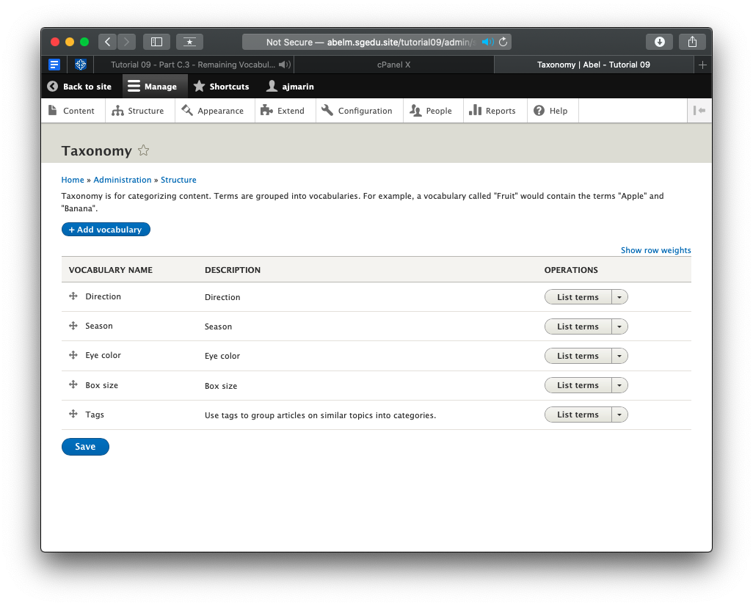] [C01]
2. SCREEN CAPTURE – Backend Term list of each Vocabulary  
   Admin toolbar > Structure > Taxonomy > Select List Terms for Box size Vocabulary Name[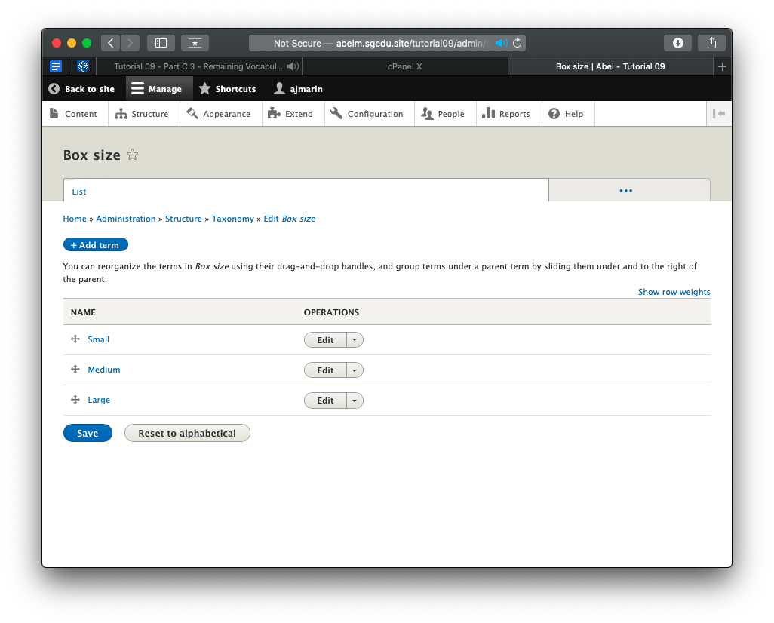] [C02]
3. SCREEN CAPTURE – Backend Term list of each Vocabulary  
   Admin toolbar > Structure > Taxonomy > Select List Terms for Direction Vocabulary Name[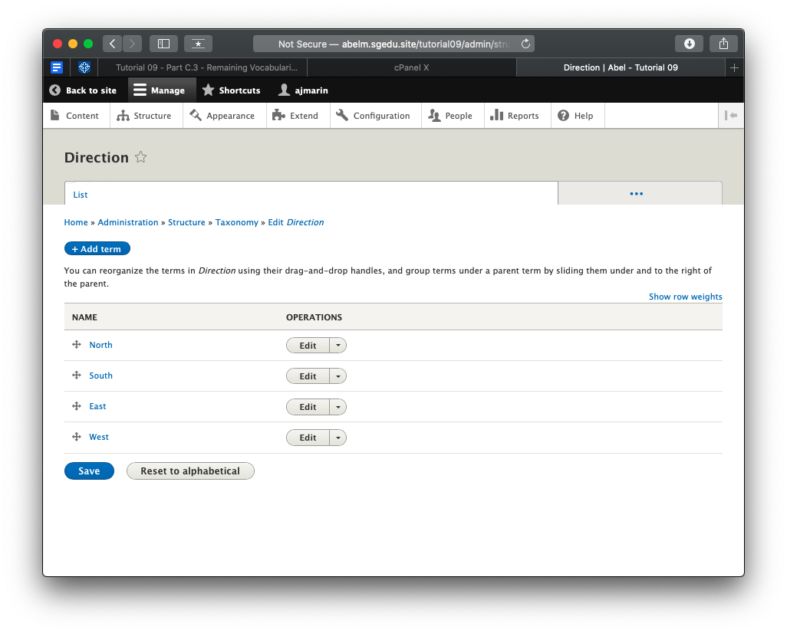] [C03]
4. SCREEN CAPTURE – Backend Term list of each Vocabulary  
   Admin toolbar > Structure > Taxonomy > Select List Terms for Eye Color Vocabulary Name[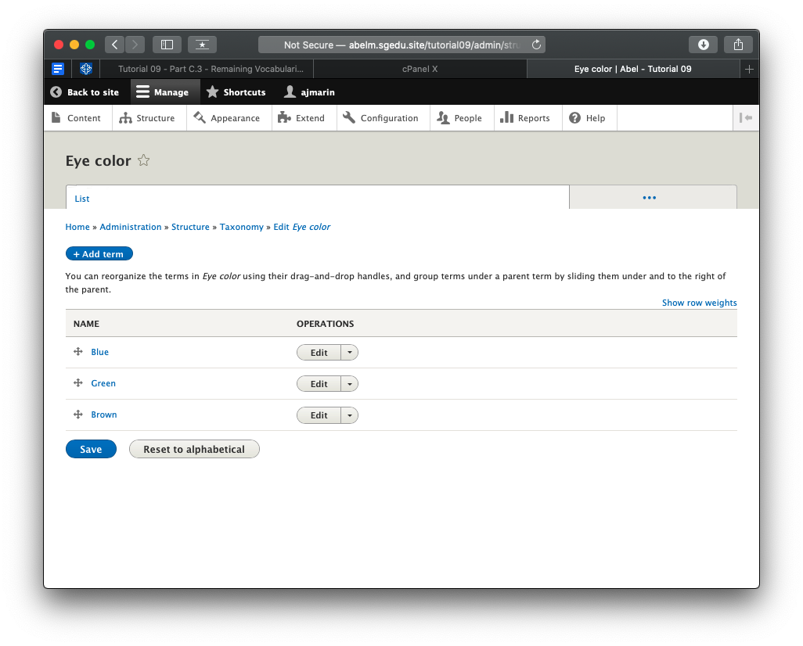] [C04]
5. SCREEN CAPTURE – Backend Term list of each Vocabulary  
   Admin toolbar > Structure > Taxonomy > Select List Terms for Season Vocabulary Name[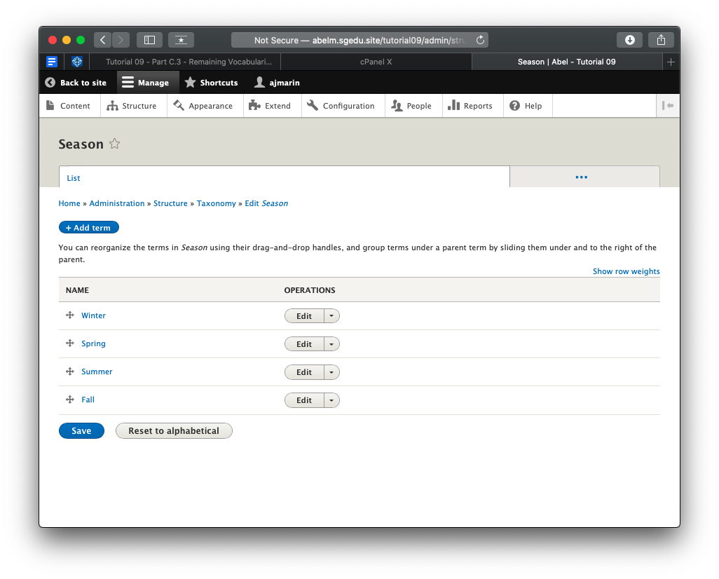] [C05]

Go back to the instructions and continue with Part D.

Part D - Extending Drupal 8 with Custom Content Types

1. SCREEN CAPTURE – Backend list of Content Type created   
   Admin toolbar > Content, Filter content by Product before taking screen capture[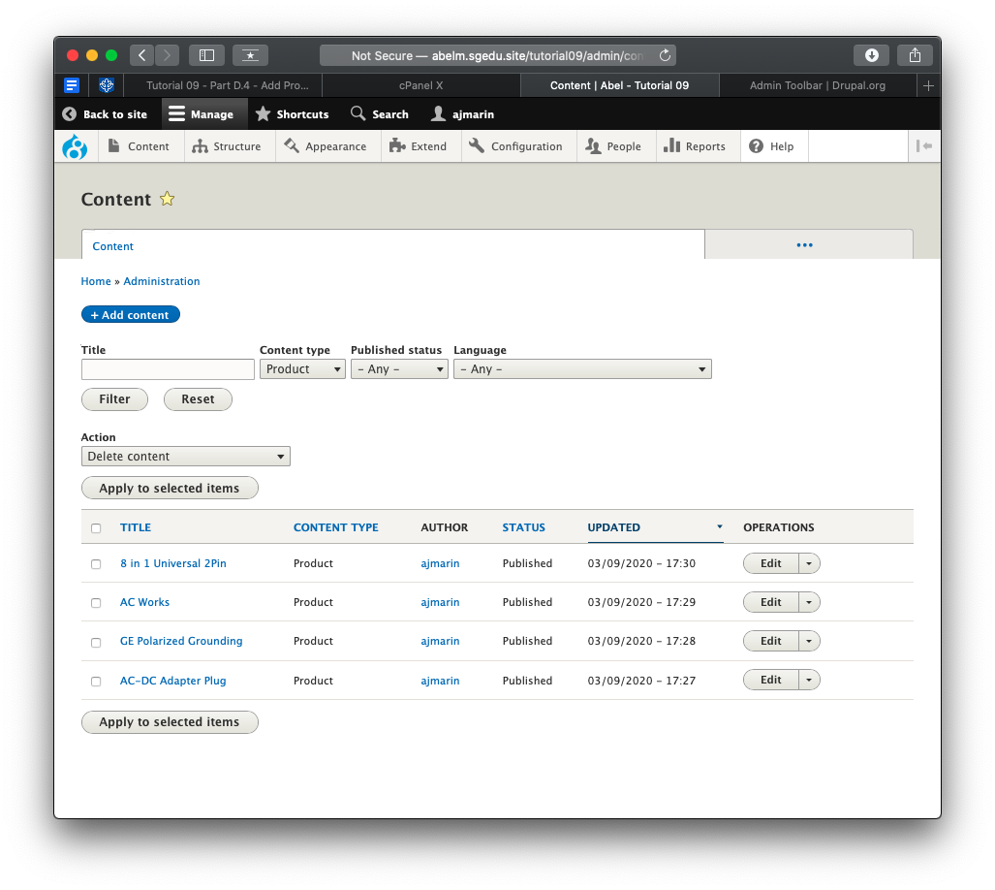] [D01]
2. SCREEN CAPTURE – Backend list of Content Type created   
   Admin toolbar > Content, Filter content by Employee before taking screen capture  
   [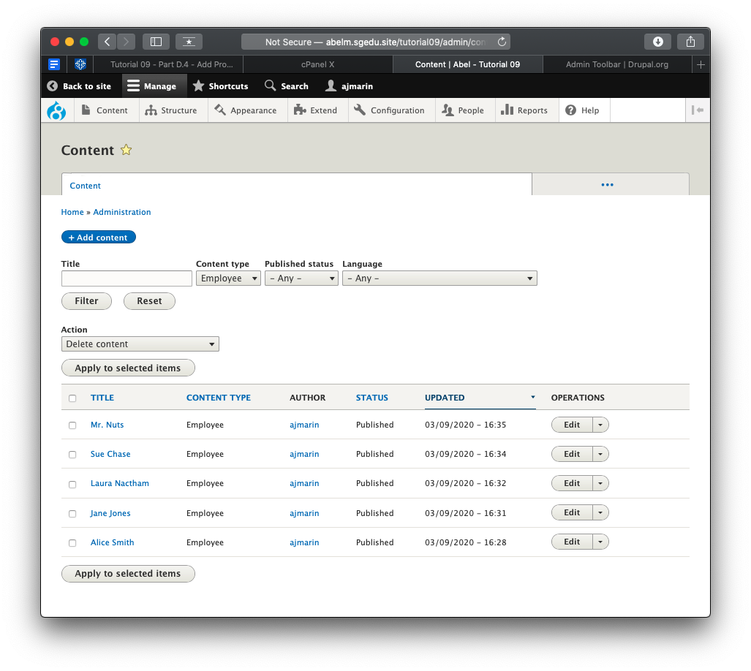] [D02]
3. SCREEN CAPTURE – Backend list of Content Type Structures   
   Admin toolbar > Structure > Content types, Product   
   [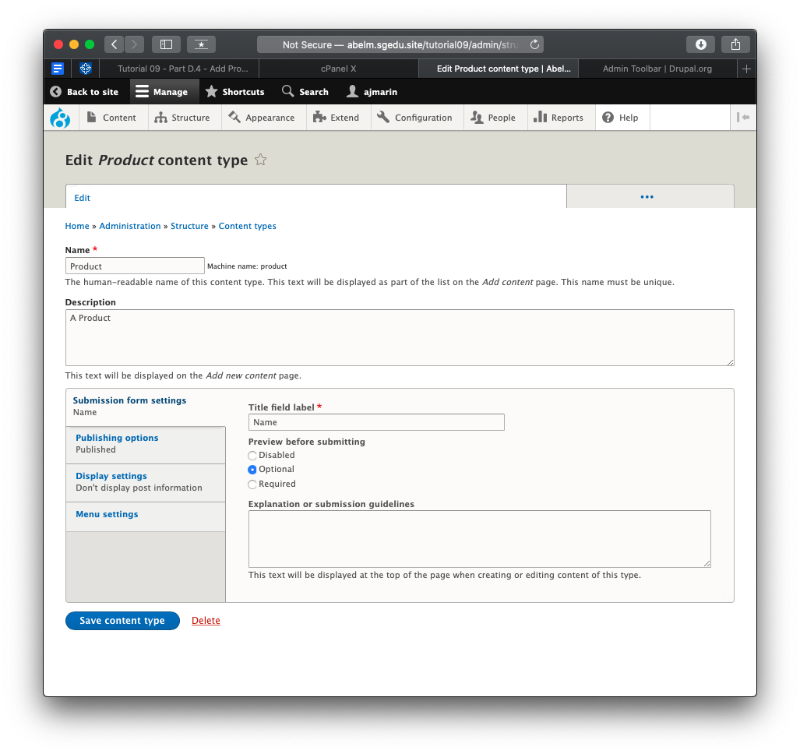] [D03.1]  
   [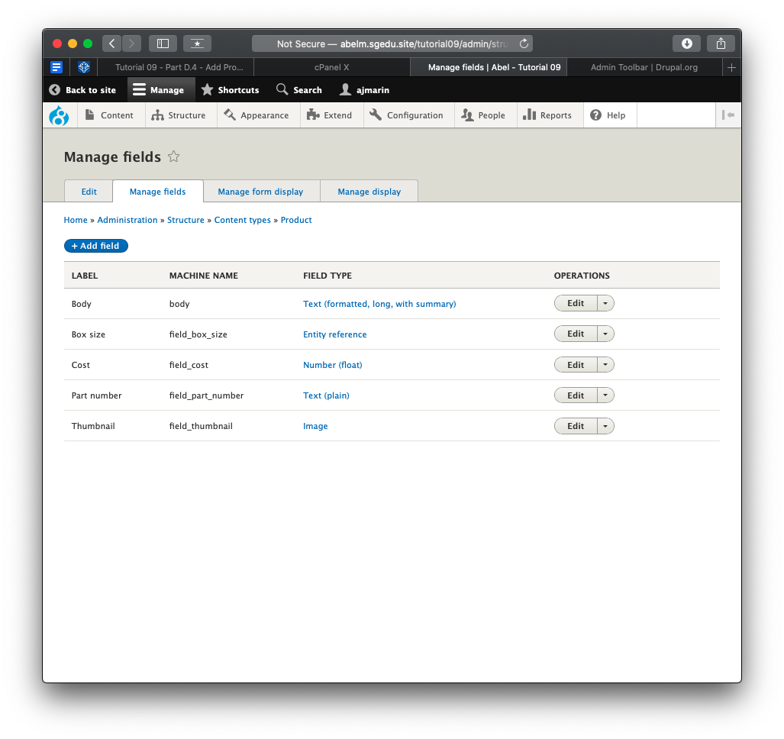] [D03.2]  
   [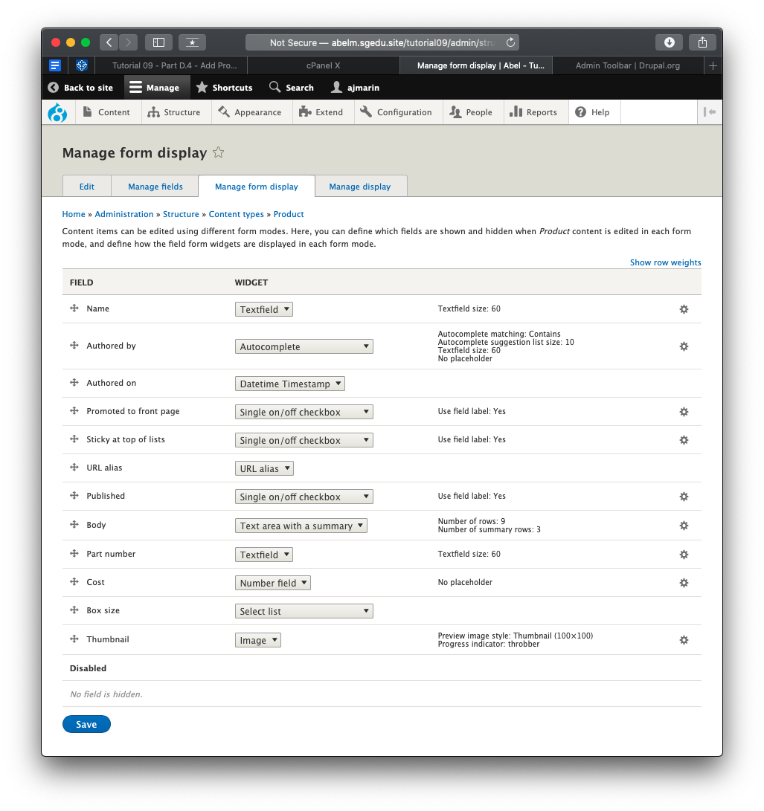] [D03.3]  
   [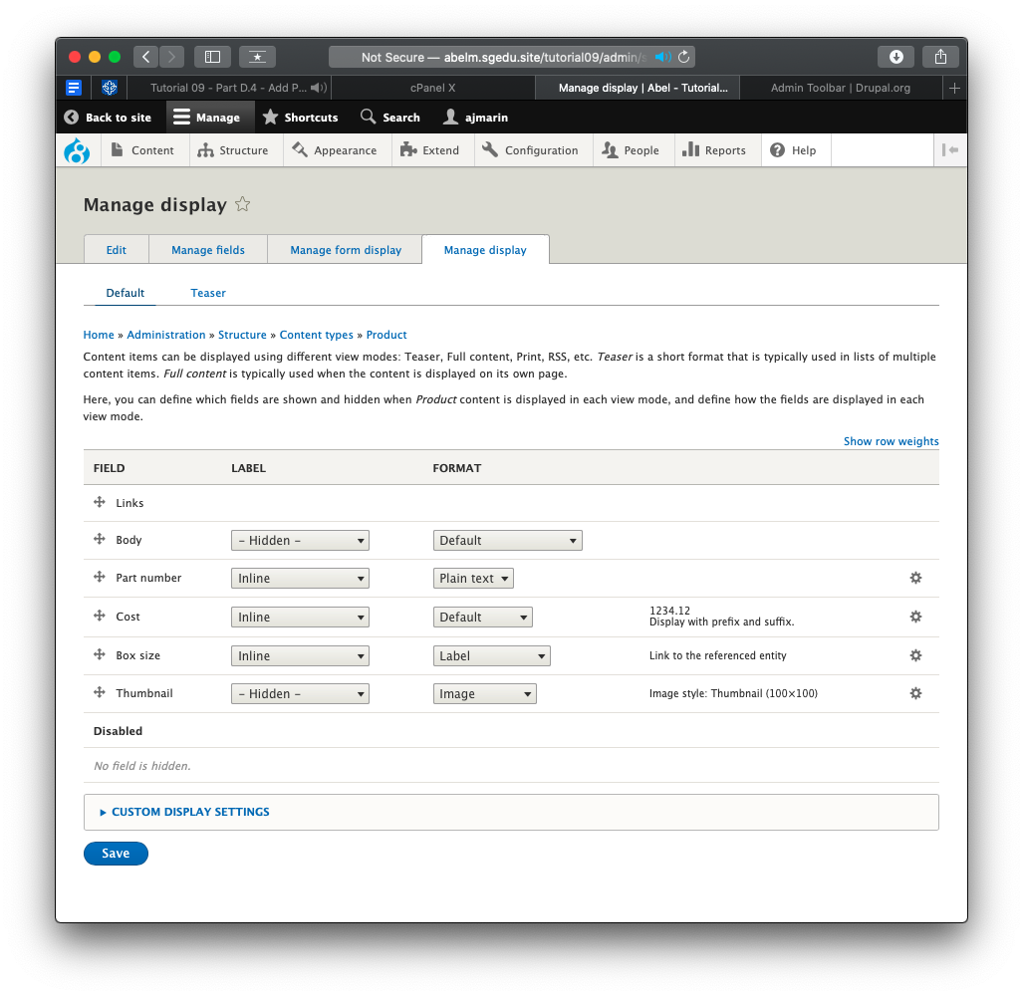] [D03.4]
4. SCREEN CAPTURE – Backend list of Content Type Structures   
   Admin toolbar > Structure > Content types, Employee   
   [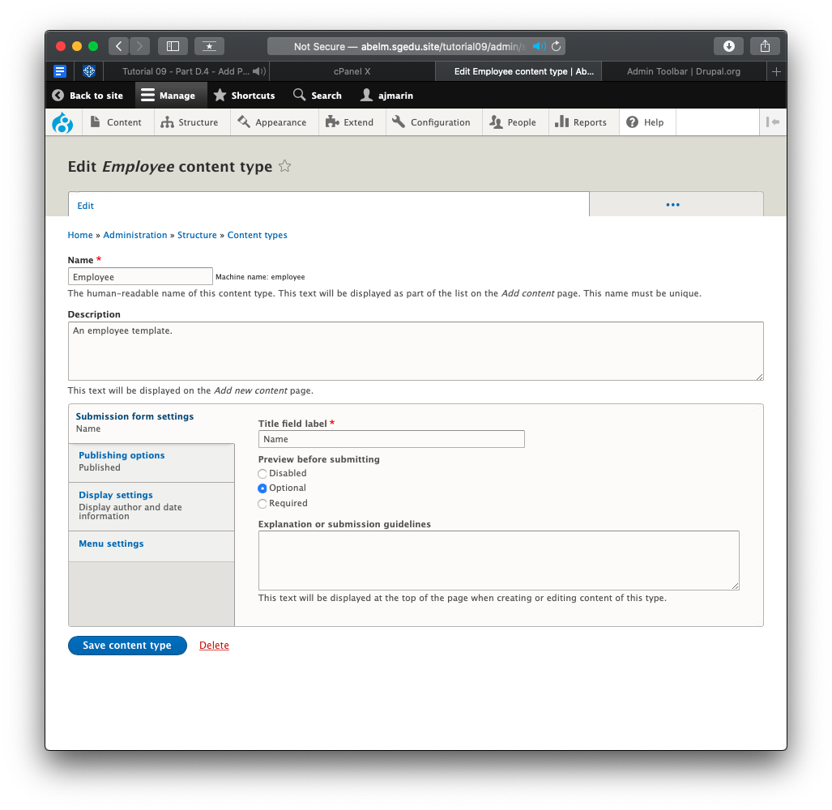] [D03.1]  
   [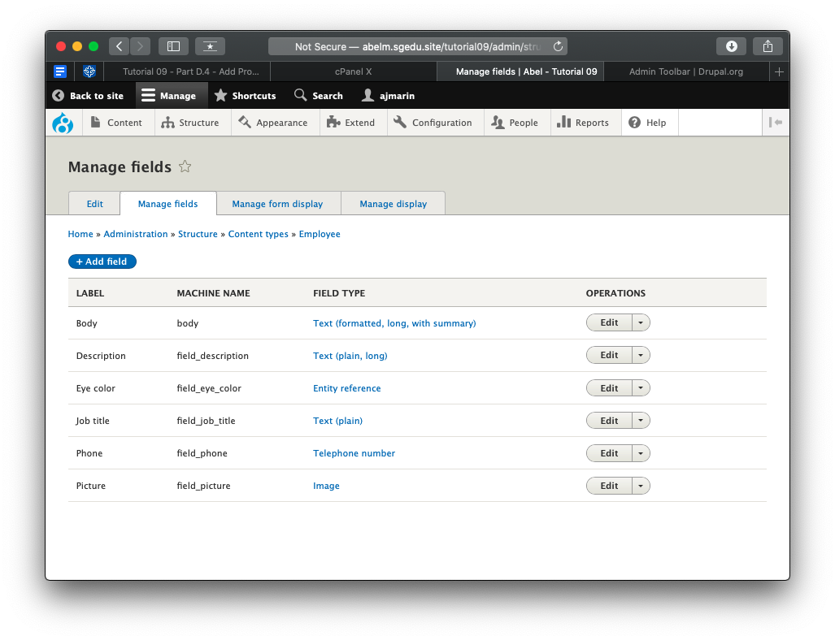] [D03.2]  
   [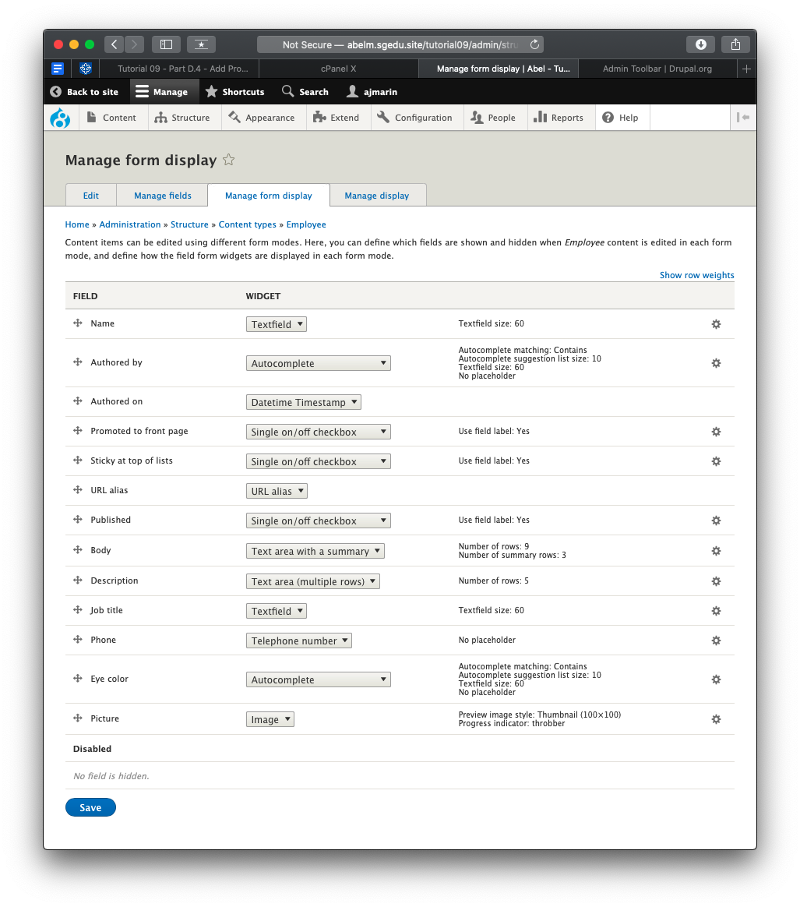] [D03.3]  
   [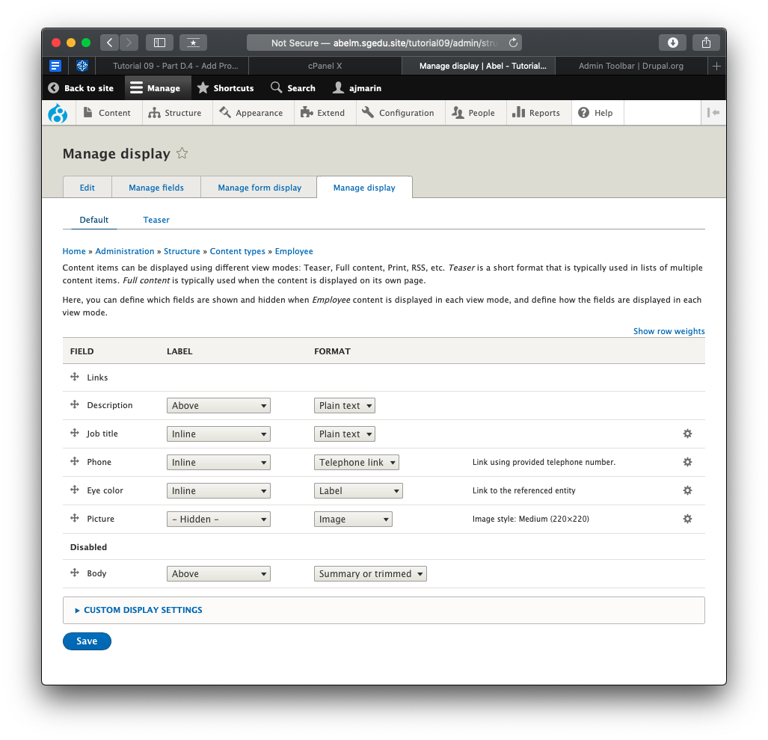] [D03.4]
5. Go back to the instructions and continue with Part E.

Part E – Extending Drupal 8 with Views

1. SCREEN CAPTURES – Backend Views List page  
   Admin toolbar > Structure > Views with the “My” Employee and Product views visible before taking screen capture[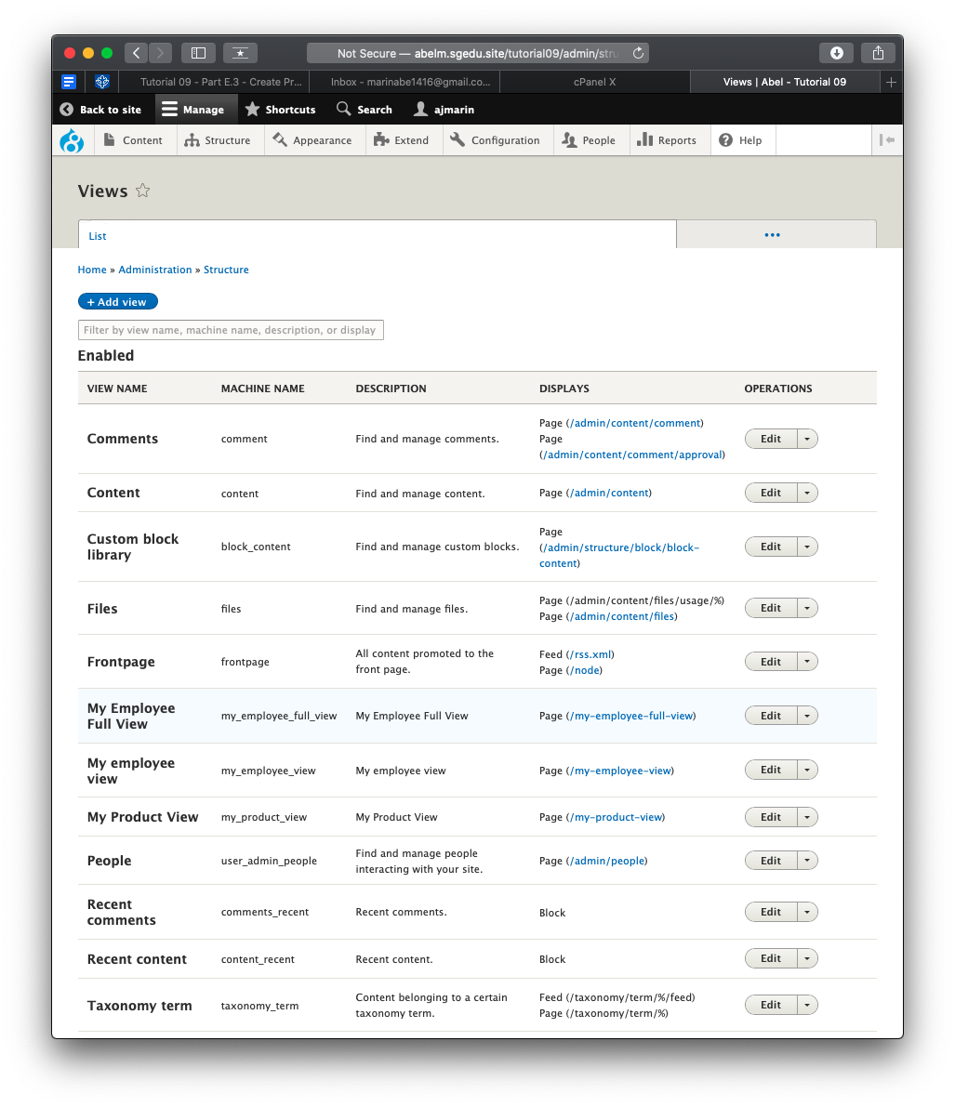] [E01]
2. SCREEN CAPTURES – Backend View summary of a Product view   
   Admin toolbar > Structure > Views, select a Product view

[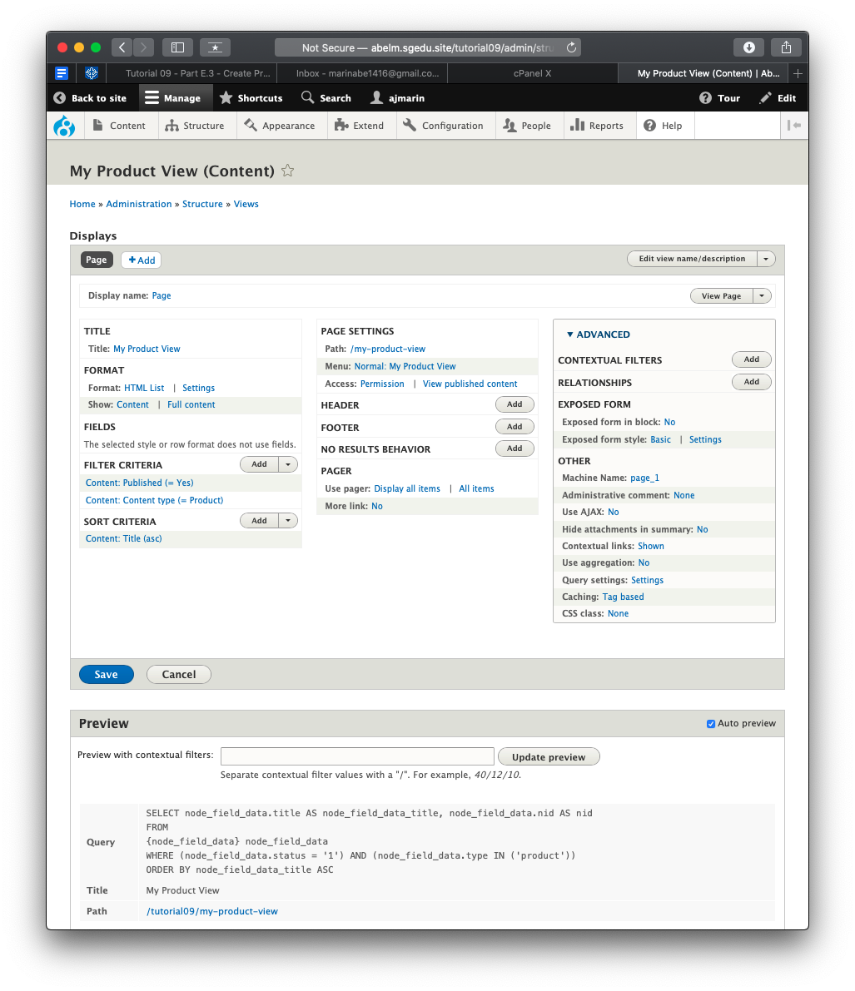] [E02.1]  
[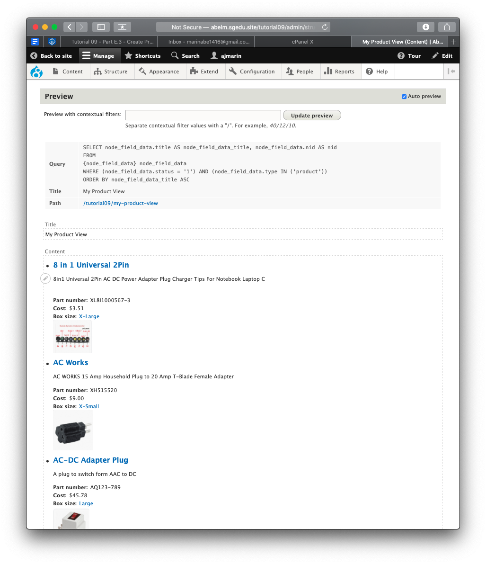] [E02.1]

1. SCREEN CAPTURES – Backend View summary of an Employee view   
   Admin toolbar > Structure > Views, select an Employee view  
   [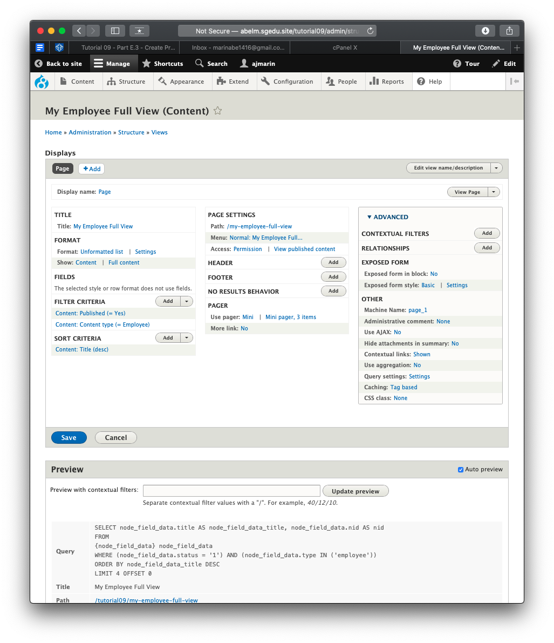] [E03.1]  
   [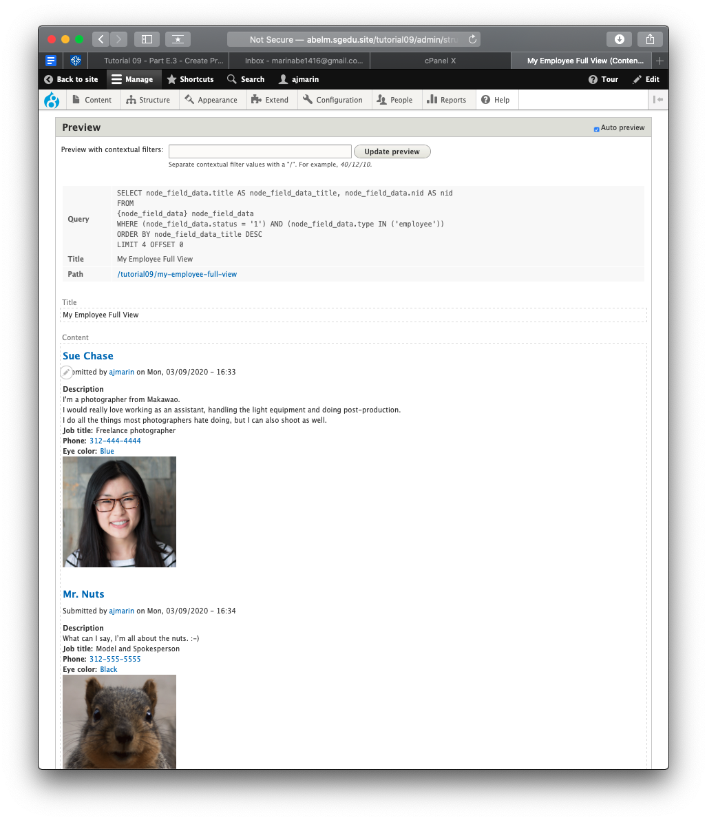] [E03.1]
2. SCREEN CAPTURES – Front End Client Facing capture of the Product view   
   Please make sure the web browser address bar is visible on your capture  
   [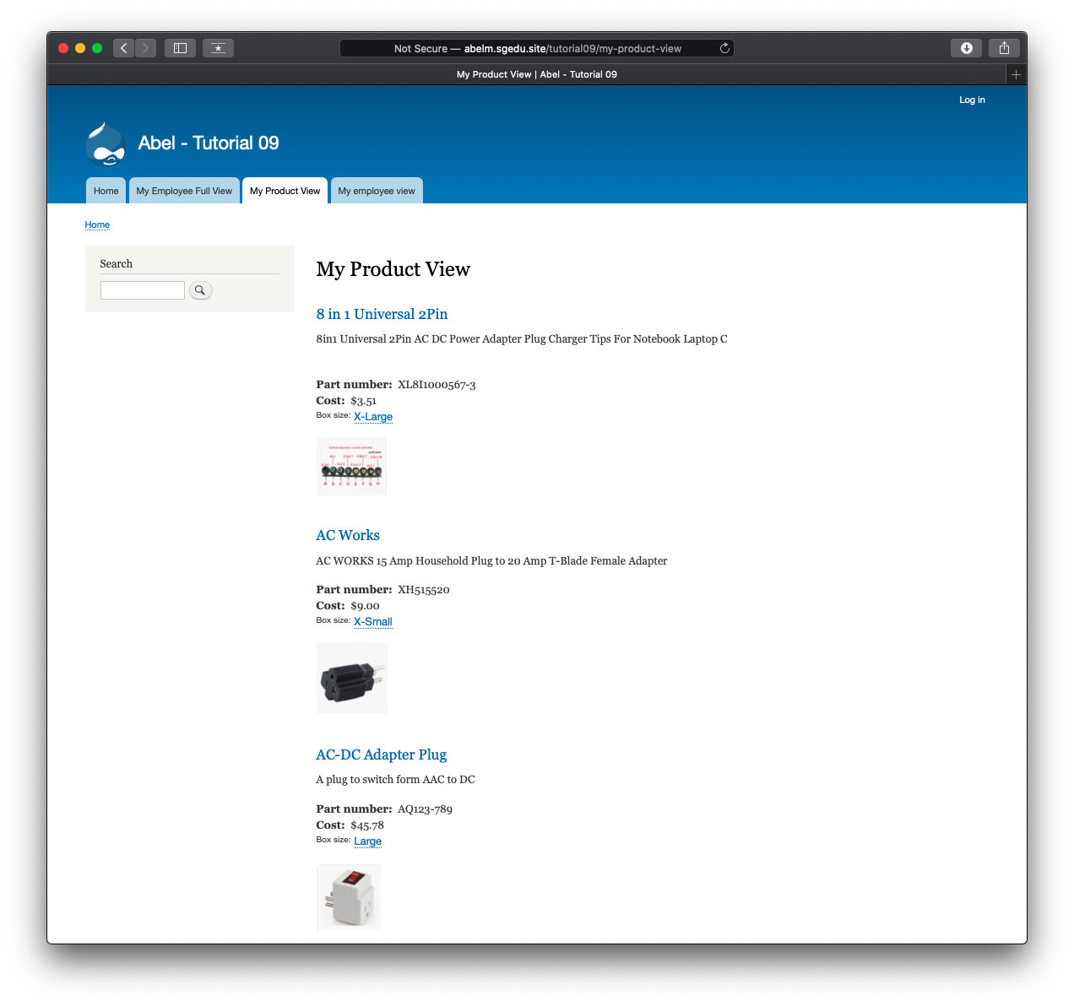] [E04]
3. SCREEN CAPTURES – Front End Client Facing capture of the Employee view   
   Please make sure the web browser address bar is visible on your capture  
   [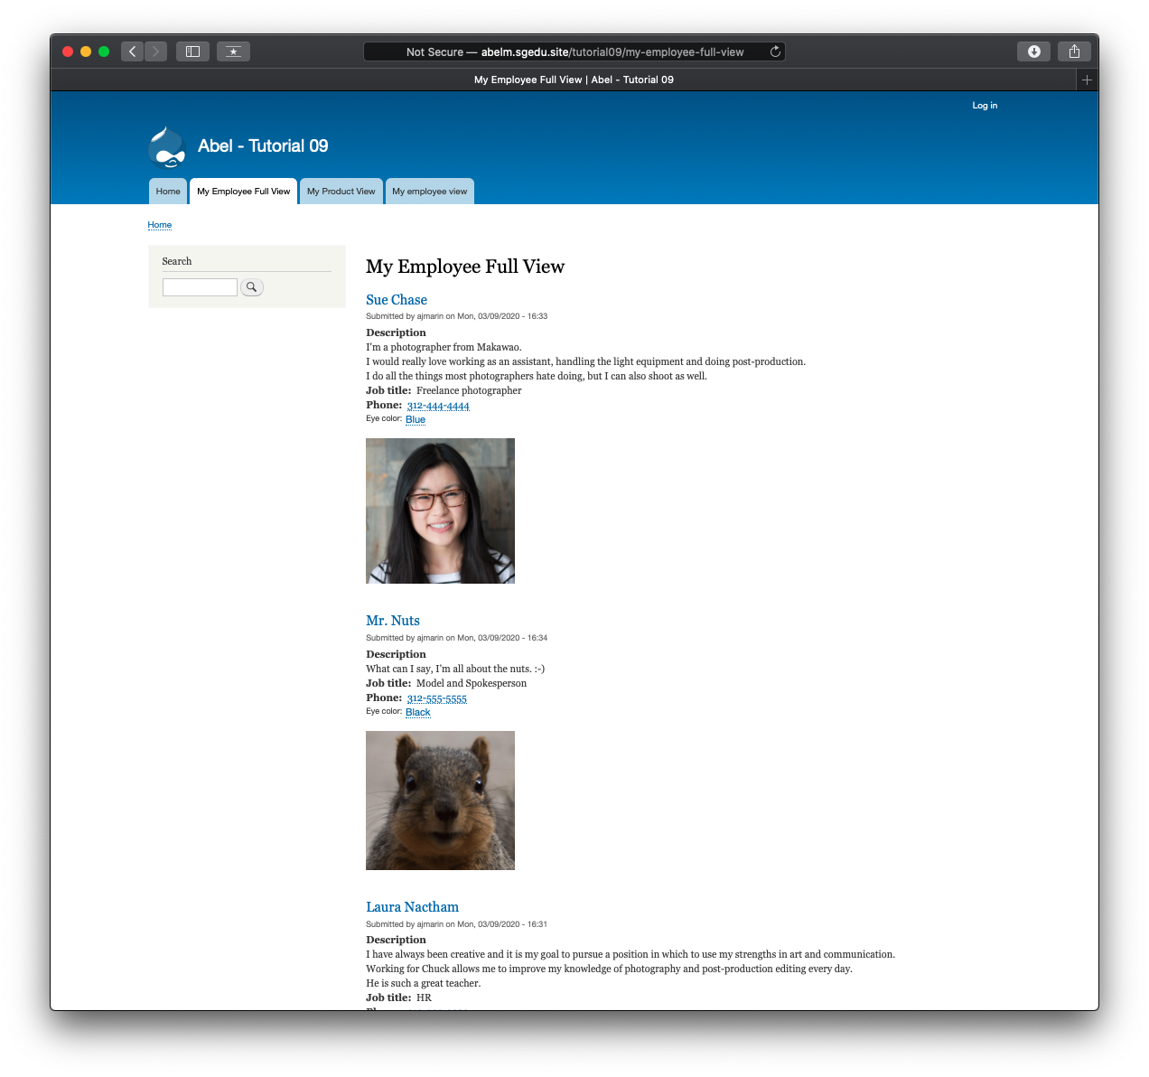] [E05]

Part F – Extending Drupal through Webforms

1. SCREEN CAPTURE – Backend List of Extend List of Modules with only the Webforms panel enabled, showing Webform and Webform UI enabled.  
   Admin toolbar > Extend, Webforms[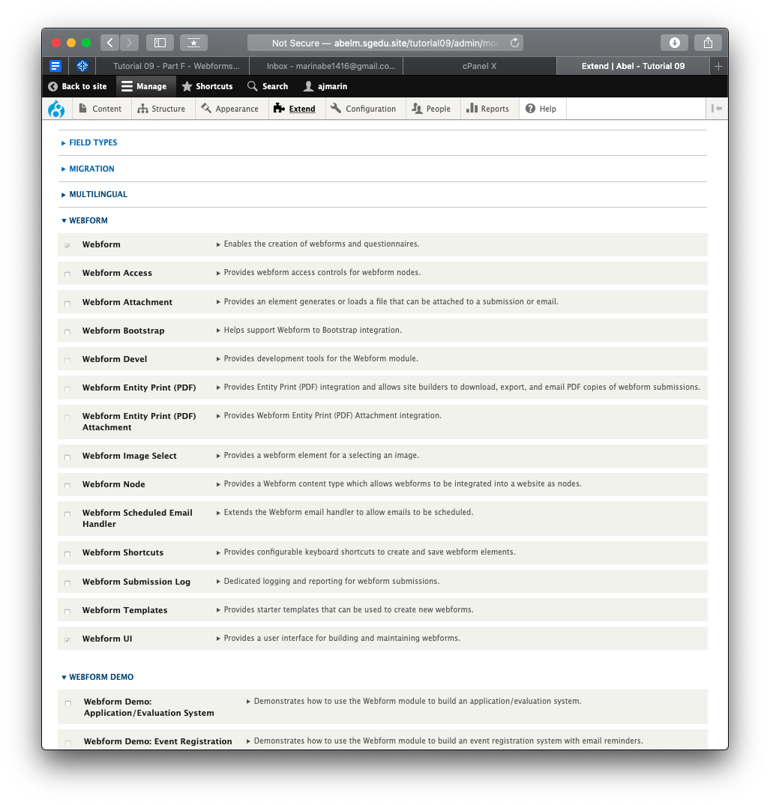] [F01]
2. SCREEN CAPTURE – Backend Webform structure  
   Admin toolbar > Structure > Webforms , Select Build on the Contact Webform[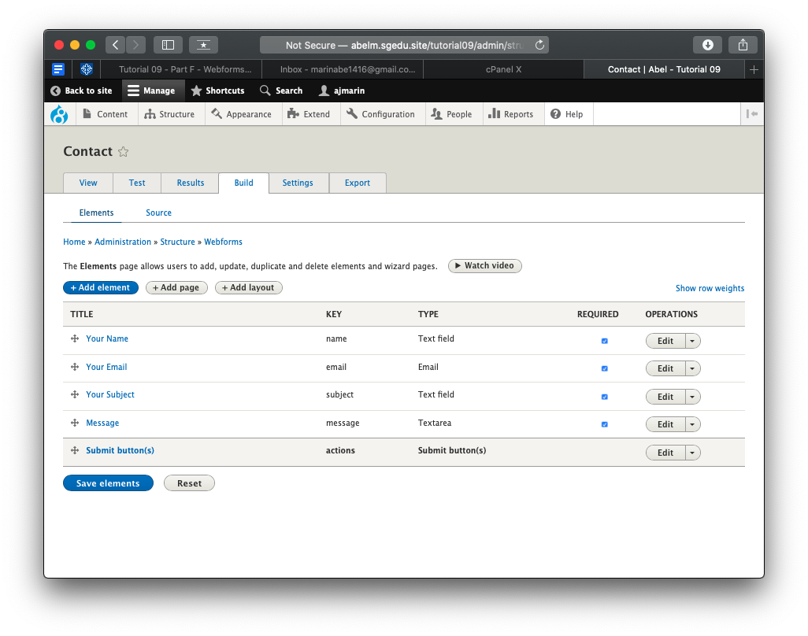] [F02]
3. SCREEN CAPTURE – Backend Webform added to Main navigation menu  
   Admin toolbar > Structure > Menus , Edit Main navigation menu  
    [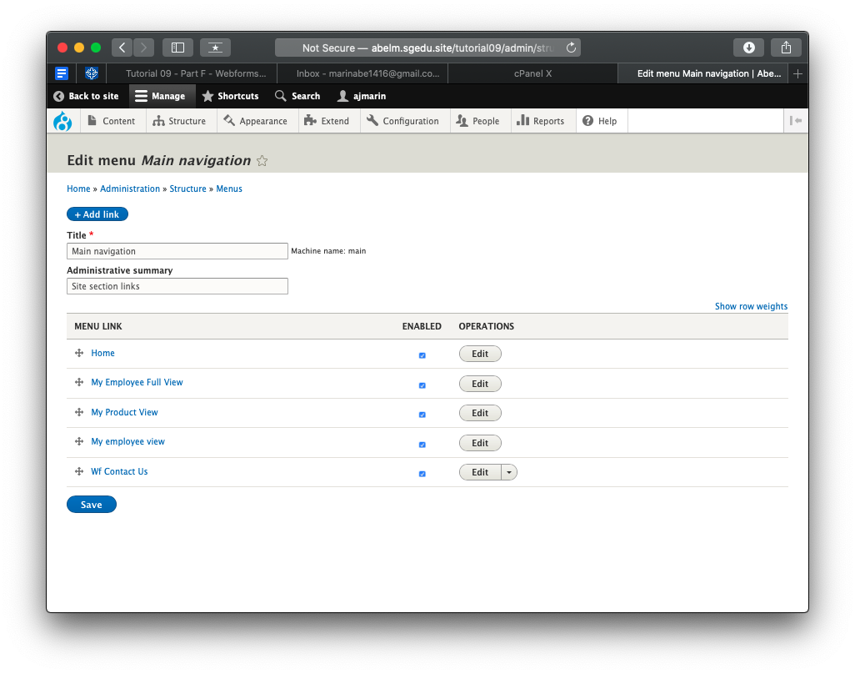] [F03]
4. SCREEN CAPTURE – Front end Webform selected from menu  
   Note: Frontend means a web browser where you are not logged into the Drupal site.  
   Please make sure the web address bar is visible on your capture[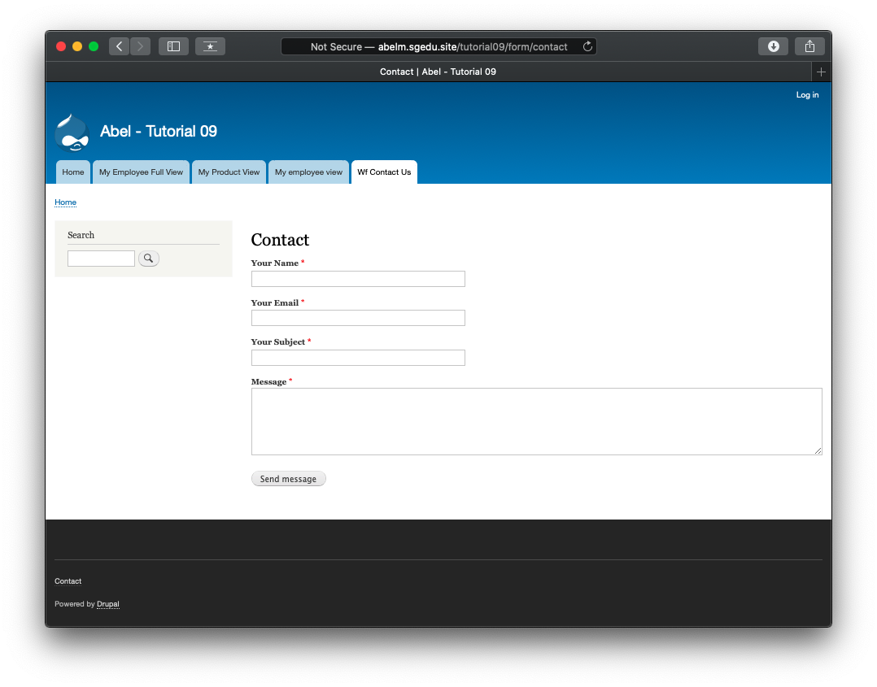] [F04]
5. Go back to the instructions and continue with Part G.

Part G – Drupal 8 Custom Modules Continued - Hooks

Codeanywhere (CA) fill out the information below:

1. **Codeanywhere (CA) Account Info: [G1]**
   * **Codeanywhere Account URL: [https://ajmassignment07-marinabe1416545968.codeanyapp.com/] [G1.1]**
   * **Codeanywhere username: [marinabe1416@gmail.com] [G1.2]**
   * **Codeanywhere password: [Dbeu!315] [G1.3]**
2. **CA Container Name:** **[ajmassignment07] [G2]**
3. **Assignment MySQL Database Information**
   * **Database Name:** **[drupal8 ] [G3.1]**
   * **Database Prefix: [drupal_] [G3.2]**
4. **MYSQL Database Info[G4]**
   * **Root Username: root**
   * **Database Password: default is no password**
5. **CA Drupal 8 Website INFO: [G5]**
   * **CA Drupal 8 Site URL:** **[https://ajmassignment07-marinabe1416545968.codeanyapp.com] [G5.1]**
   * **CA Drupal 8 website Admin Username: [**ajmarin**] G5.2]**
   * **CA Drupal 8 website Admin Password: [Dbeu!315!315] [G5.3]**

**Please make sure that all Codeanywhere screen captures show the top of web browser and the Codeanywhere web URL in the address bar**

1. SCREEN CAPTURE – Backend Account Settings, REGISTRATION AND CANCELLATION **[G6]**  
   Admin toolbar > Configuration > Account settings, Registration and Cancelation

Please make sure your screen capture has all of the following (see example image below):

1: Web browser address bar is visible

2: Druapl 8 Root folder is expanded

3: Drupal 8 custom module folder is fully expanded  
4: All hello_world files are visible

5: the hello_world.module is selected and visible on the editor 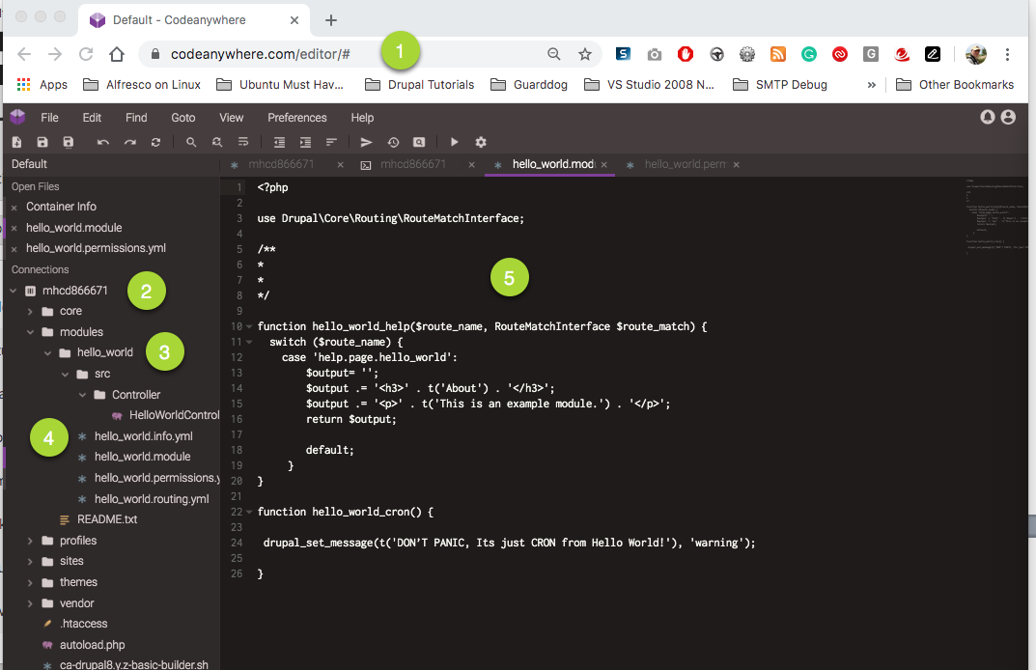

[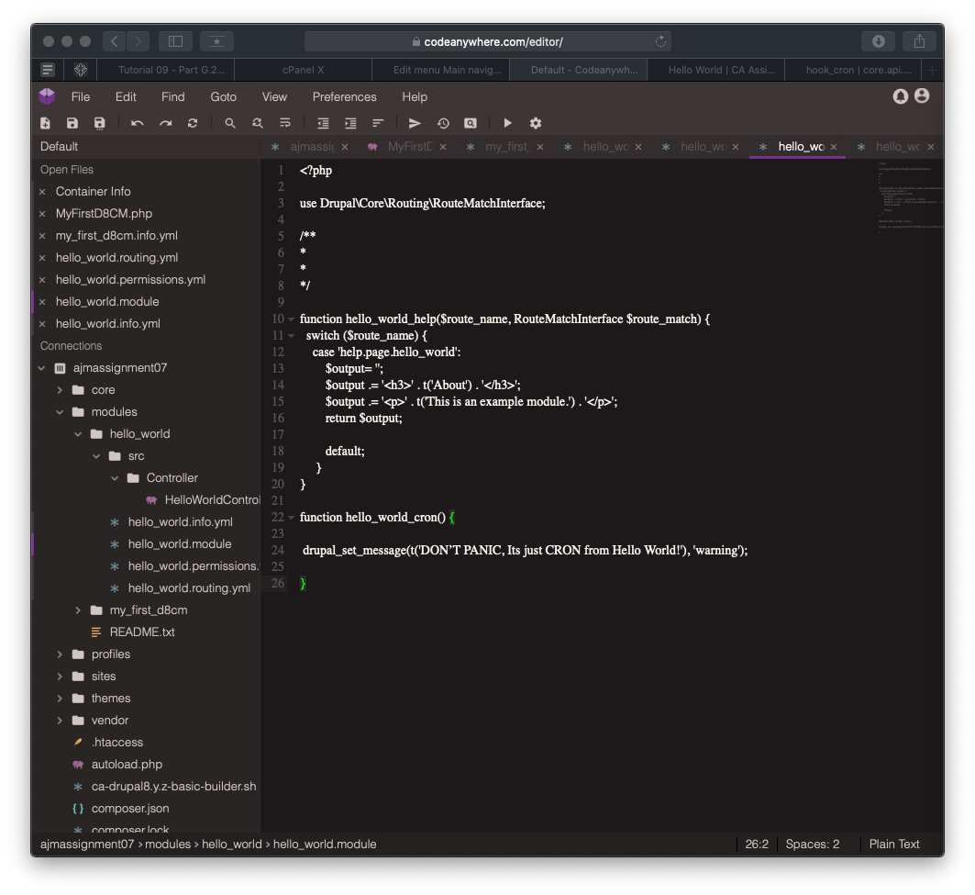]

1. SCREEN CAPTURE – Drupal 8 Backend with the Hello World Help page showing   
   Admin toolbar > Extend > Hello World, Select the Help link [G7]  
   [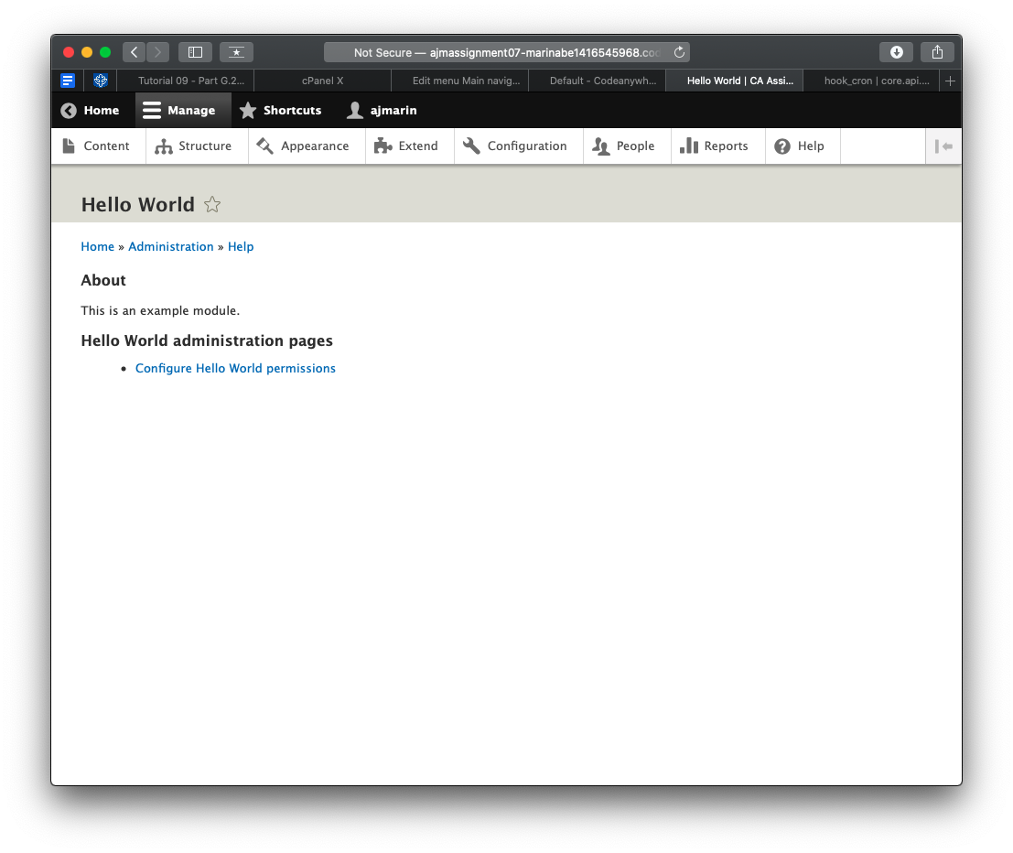]
2. SCREEN CAPTURE – Drupal 8 Backend People > Permissions page with the Hello World Permission showing [G8]  
   Admin toolbar > Extend > Hello World, select the Permissions link  
   [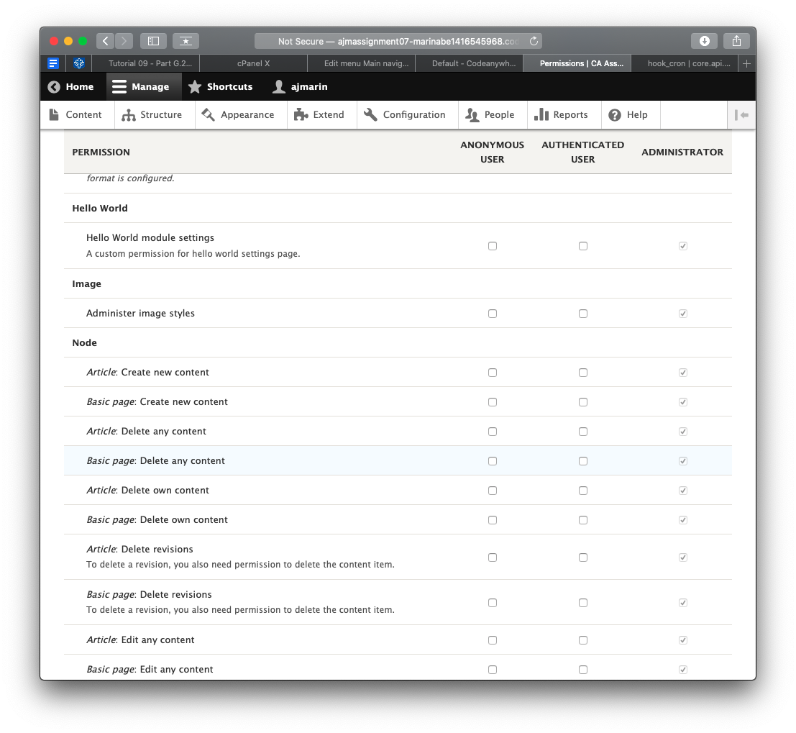]
3. SCREEN CAPTURE – Frontend screen captures of the Hello world plugin page by adding “/hello/world” to the base site URL – permission denied should display [G9]  
   Note: Frontend means a web browser where you are not logged into the Drupal site.  
   [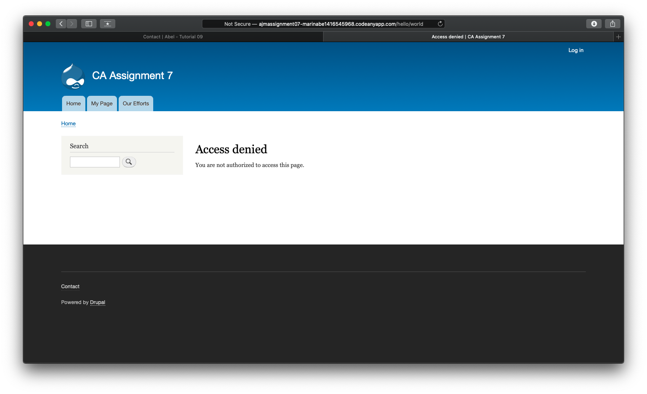]
4. SCREEN CAPTURE – BACKEND screen capture (LOGGED in as site admin) of the Hello world plugin page by adding “/hello/world” to the base site URL[G10]  
   Note: Frontend means a web browser where you are not logged into the Drupal site.  
   [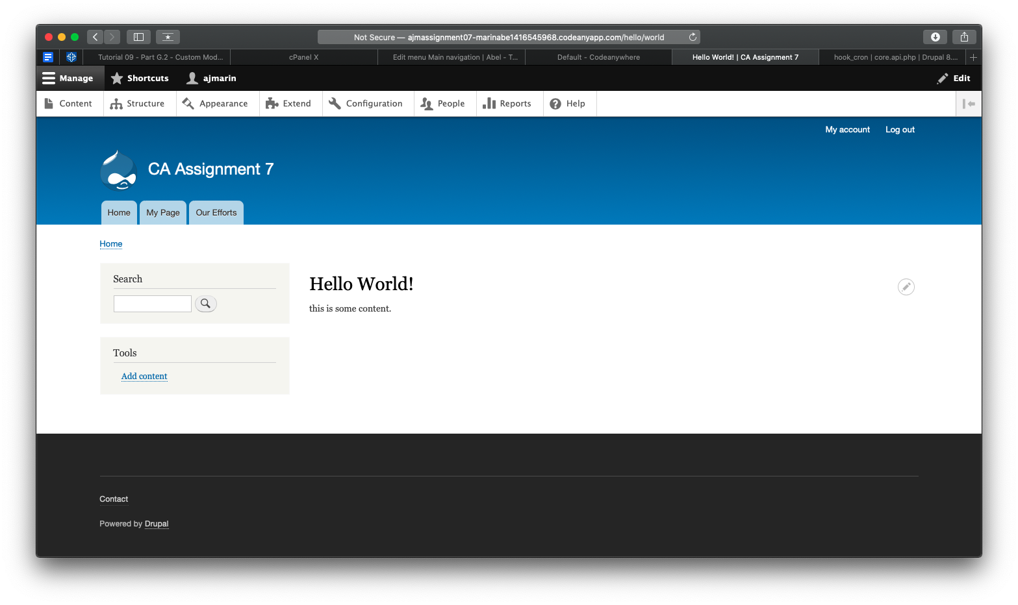]

Part H – Drupal 8 JavaScript Library Install

For Shared Web Host (SWH):

1. SCREEN CAPTURE – cPanel File Manager with Drupal 8 site folder expanded and the libraries folder visible with the FlexSlider zip file and the new flexslider folder visible [H1-SWH]  
   [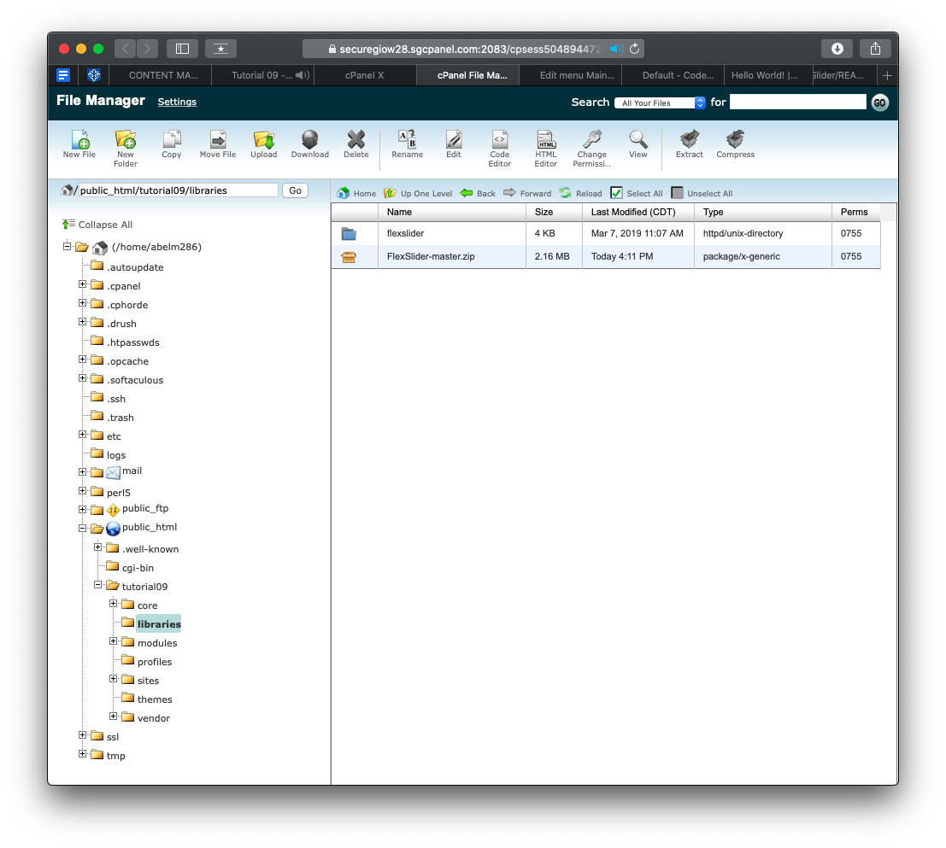]

For Pantheon (PaaS):

1. SCREEN CAPTURE – FileZilla destination (sever) folder with Drupal 8 site folder expanded and the libraries folder visible with the FlexSlider zip file and the new flexslider folder visible [H1-Paas]  
   [SCREEN CAPTURE HERE]

For Codeanywhere:

1. SCREEN CAPTURE – Fully expanded Drupal 8 root folder with the libraries folder visible with the FlexSlider zip file and the new flexslider folder visible [H2]  
   [